05 Jan
- Clone git directory
- Then add -mkdrt Frontend
- Install node.js npx create-next-app@latest . , by using this we create Next.js app
- Next.js app install files like -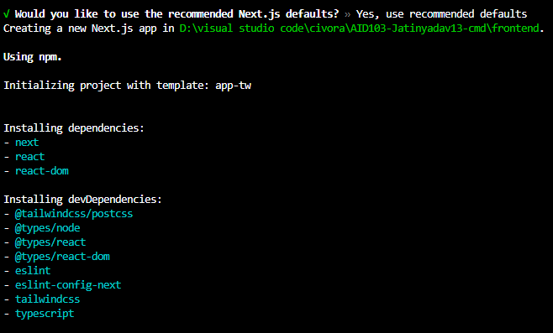
- added 356 packages, and audited 357 packages in 2m
- then we use , npm run dev ,, The npm run dev command is a custom script that initiates your project in development mode, typically by starting a local development server
- After that Node.js take permission to run .
- 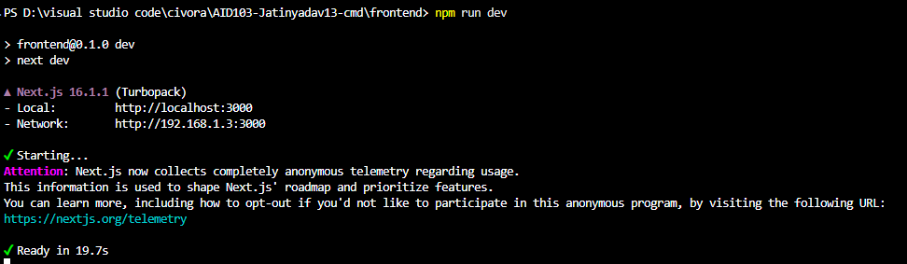
- This means the next.js app is running at local host 3000
- Now commit frontend repository in github.
- Steps to push frontend to main
- -git checkout main
- -git pull origin main
- -git add frontend/
- -git commit -m "feat: add CropGuard frontend setup and homepage"
- -git push origin main

What you’ve successfully completed

- Repo cloned correctly
- Next.js frontend set up in frontend/
- CropGuard homepage added
- Changes committed to main
- Code pushed and visible on GitHub
- 9/01/26 – working on backend ,
- Initialize node.js backend
- Npm init -y
- Npm install express cors
Work on login page
Worked on dashboard using node.js
14.01.2026
Today we work on training model (crop_classification), and test it on test dataset and tune on validation dataset. To train this firstly we create our virtual environment to run our library without any interruption .
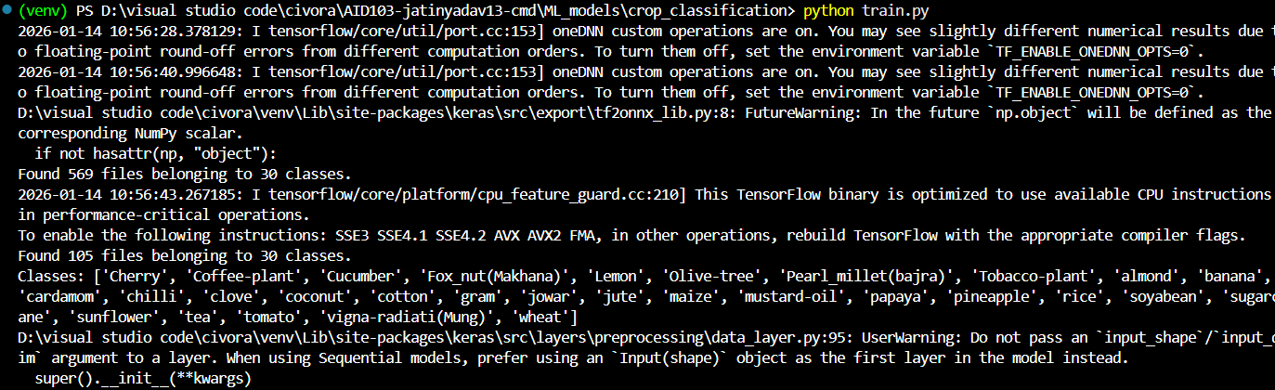
Now we train our model on 15 epochs .with total parameters of 84 mb .
Training of model.
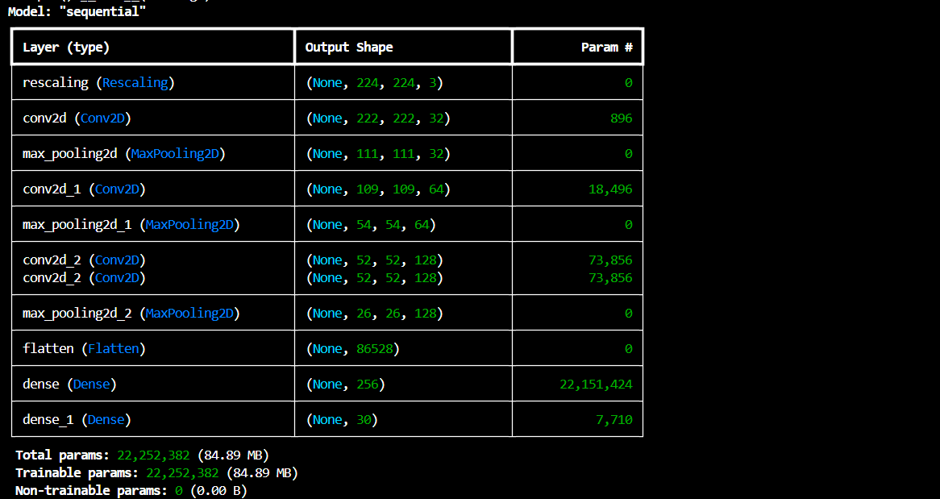
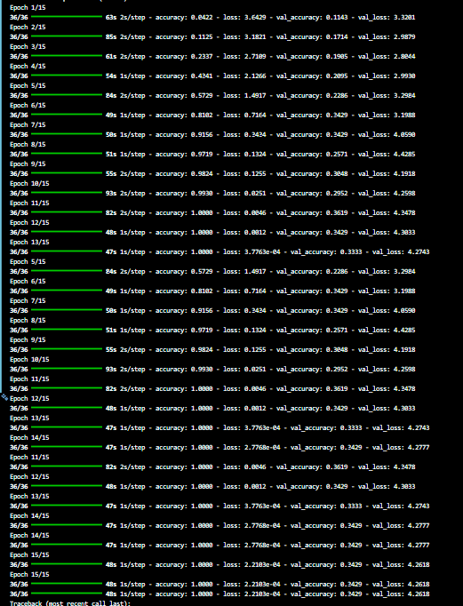
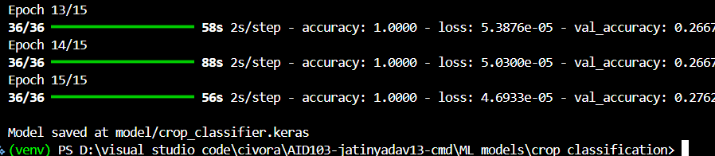
Model trained successfully and give result on test image.
This model is not satisfied so we can use MobileNet to train and see what will happen.
I change my code of train.py with new one including MobileNet and improving data augmentation to deal with small dataset , and we use early stopping to deal with overfitting and softmax .
And the result came out that was.
